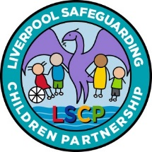

Liverpool

Multi-Agency
Self-Harm
Practice Guidance

April 2021

Review Date: April 2023

Multi-Agency Process Flowchart for Managing Self Harm
PREVENTION
Reduce risk of self-harm by building resilience, ensuring good communication skills and improve awareness of warning signs.
Young person shows signs/symptoms of self-harm OR self/peer disclosure of thoughts of self-harm OR suspected or self/peer disclosure of recent or previous self-harm.

Staff member comforts, acknowledges, reassures and responds to young person. Safeguarding lead is notified.

Safeguarding lead assesses risk and identifies most appropriate member of staff to meet young person’s needs, considering trusted adults for young person.

HIGH RISK

CRISIS
- Locate young person. Comfort, Acknowledge, Reassure, Respond.
- Contact emergency services if injury is life threatening or if young person is suicidal.
- If young person has taken an overdose, take to A&E.
- Administer first aid if required.
- Inform Designated Safeguarding Lead.
- Contact the young person’s parents/carers, unless it places the young person at further risk.
- Consider environment and those who might be affected by witnessing the incident.
- If the young person is taken to hospital, emergency protocols in A&E will be implemented and referral to Alder Hey CAMHS activated.

NOT CRISIS
- Comfort, Acknowledge, Reassure, Respond.
- Urgent referrals to 24/7 Crisis line freephone or 0151 293 3577 (out of office hours or in crisis).
- Follow safeguarding procedures and refer to Careline 0151 233 3700 if obvious safeguarding concerns of immediate risk to the child. (MARF – Multi Agency Referral Form).
RAISED RISK

- Comfort, Acknowledge, Reassure, Respond.
- Offer supportive strategies/safety net.
- Explain confidentiality and consent.
- Encourage and help young person to link to sources of support in organisation.
- Contact the young person’s parents/carers, unless it places the young person at further risk.
- Initiate EHAT to co-ordinate appropriate support for young person.
- Follow safeguarding procedures and refer to Careline 0151 233 3700 if obvious safeguarding concerns of immediate risk to the child (MARF).
LOW RISK

- Comfort, Acknowledge, Reassure, Respond.
- Offer supportive strategies/safety net.
- Explain confidentiality and consent.
- Encourage and help young person to link to sources of support in organisation.
- Contact the young person’s parents/carers, unless it places the young person at further risk.
- Consider initiating an EHAT – consider if / what support is needed for the wider family.

If child is open to CAMHS services, contact CAMHS practitioner. Otherwise contact Alder Hey: freephone 08081 963 550 or 0151 293 3577 for advice and guidance.
You could also contact the young person’s GP.
Schools can speak to their EMHT practitioner/service.
Contact Alder Hey: freephone 08081 963 550 or 0151 293 3577 for advice and guidance.
You could also contact the young person’s GP.

Review onward support plan on young person’s return to setting.
Ensure young person has a trusted person who can offer support and is the link into a coordinated approach to ongoing wider multi agency support. Consider mental health needs in addition to the self-harm risk.
Ensure there is a plan to provide help and support and that the young person understands it. Consider mental health needs in addition to the self-harm risk.

Debrief with safeguarding lead/senior colleagues and set professional action plan. Ensure staff members are supported and offered supervision as appropriate. Ensure incident is logged.
Self-Harm- Guidance on Levels of Risk and Management

HIGH RISK

- Frequent suicidal thoughts which are not easily dismissed.
- Specific plans with access to potentially lethal means.
- Evidence of current mental illness.
- Significant drug or alcohol use.
- Situation felt to be causing unbearable pain or distress.
- Increasing self-harm, either frequency, potential lethality or both.

LOW RISK

- Suicidal thoughts are fleeting and soon dismissed.
- Few or no signs of depression.
- Any mood changes are transient.
- Superficial cutting.
- No other self-harming behaviour.
- Sensible attitude to experimentation with drugs and alcohol.
- Nothing to indicate past or present abuse.
- Current problem situation felt to be painful but bearable.
PREVENTION

- By being aware of students who display the risk factors associated with self-harm (see section 4).
- By being alert to any specific incident that might trigger an act of self-harm.
- By being alert to changes in demeanor and behaviour that suggest anxiety or low mood.
- Observing expressions of hopelessness or suicidal feelings.
- Observing behaviour change – some may become withdrawn and isolated, others may become disruptive or more animated.
- Building resilience in children and young people.
- Breaking the cycle of ACEs.

RAISED RISK

- Suicidal thoughts are frequent but still fleeting.
- No specific suicidal plan or immediate lethal intent.
- Showing indicators of current mental health disorder especially depression, anxiety and eating disorder.
- Scarring or cutting.
- Previous history of overdose or other self-harm.
- Significant or potentially dangerous drug or alcohol use.
- Showing indicators of possible abuse or significant traumatic experience.
- Problem situation felt to be painful but no immediate crisis.
- Recent experience of bereavement or loss.
- Experienced bullying, both face to face or online.
- Experiencing academic pressures, especially related to exams.
- Experiencing physical health conditions that are longstanding or have a social impact.

Contents | Page
Introduction | 5
- What is self-harm? | 5
- How many young people are affected by self-harm? | 8
- Why do young people self-harm? | 9
- Becoming self-harm aware | 11
- What to do if a young person makes a disclosure | 13
- When hospital care is needed | 15
- Follow up | 16
- Confidentiality and information sharing | 16
- What to do next | 18
- Support for practitioners | 20

Appendices

Useful publications 21
Research articles 22

Toolkit 23-44

INTRODUCTION

This document has been developed as a reference guide for all agencies and practitioners who come into contact with children, young people and their families. It is intended as a guide to supporting children/ young people who have thoughts of, are about to or have self-harmed.

The guidance will support practitioners to keep children safe by outlining:

What self-harm is | The triggers for self-harm | How to support young people and children who self-harm

Agencies and practitioners must refer to the Liverpool levels of need framework (www.liverpoolcamhs.com/about/pathway/) to help them in their decision making about the level of need and the most appropriate assessment and interventions, including early help and referral to Children’s Social Care. Where there are serious or complex needs or where there are safeguarding concerns, practitioners should consult with their designated lead for safeguarding and, where appropriate, make a referral to Children's Social Care or initiate an Early Help Meeting to coordinate support.

1. WHAT IS SELF-HARM?

Self-harm is an expression of personal distress, not an illness, and there are many varied reasons for a person to harm themselves. Self-harm describes a wide range of behaviours that someone does to themselves, usually in a deliberate and private way and without suicidal intent, resulting in non-fatal injury. In the majority of cases, self-harm remains a secretive behaviour that can go on for a long time without being discovered.

Many children and young people may struggle to express their feelings and will need a supportive response to assist them to explore their feelings and behaviour and the possible outcomes for them.

Examples of self-harm behaviour:

Self-cutting or scratching | Punching/hitting/bruising
Burning or scalding oneself | Swallowing objects
Headbanging or hair pulling | Self-poisoning, i.e. taking an overdose or ingesting toxic substances
Over/under-medicating, e.g. misuse of insulin

There are other behaviours that are related to, but which do not typically fall within the definition.
These include:

Self-neglect – physical and emotional | Eating distress (anorexia or bulimia)
Reckless risk-taking | Substance misuse
Staying in an abusive relationship | Risky sexual behaviour

NICE Clinical guidance defines self-harm as 'self-poisoning or injury, irrespective of the act's apparent purpose. However, self-harm is also commonly known as self-injurious behaviour (SIB), non-suicidal self-injury (NSSI), or deliberate self-harm (DSH)

Common characteristics of self-harm behaviour

Compulsive, ritualistic | Sometimes, but not always, occurs with depression and anxiety
Episodic (every so often) | Serves a purpose to the child or young person
Repetitive (on a regular basis) | Serves as a way of communicating to others that something is wrong

Common myths about self-harm

The most common myths about most young people who self-harm are that they:

Are attention-seeking (often the opposite is true) or are manipulative | Follow a ‘Goth’ sub-culture
Do it for pleasure | Have a borderline personality disorder
Do it as a group activity | Are a risk to others

The cycle of self-harming/cutting

When a person inflicts pain upon themselve, the body responds by producing endorphins, (which are similar to the drugs opium and heroin) a natural pain-reliever that gives temporary relief or a feeling of peace. These chemicals are released when a person feels in danger, experiences fear and particularly when the body is injured in any way.

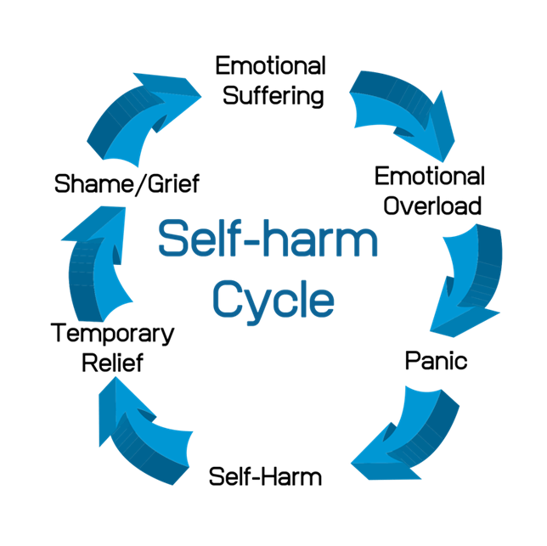
They produce an insensitivity to pain that will help the individual survive when having to deal with danger. The addictive nature of this feeling can make the stopping of self-harm difficult. Young people who self-harm still feel pain, but some say the physical pain is easier to stand than the emotional/mental pain that initially led to self-harm.

Self-harm and suicide

Suicide is a rare event, although rates have increased in recent years.

Suicide rates among young men (aged 10-24 years) have increased significantly since 2017. However, the rate among young women in 2019 was the highest recorded since 1981.

Some people who self-harm are at high risk of suicide. However, many who do self-harm do not want to end their lives; they do it to live. It is how many people cope with emotional distress, so they don’t feel the need to kill themselves.

However, there is a relationship as there is a high prevalence with suicide and self-harm. We don’t always take self-harm seriously but:

50% of those who die by suicide have previously self-harmed. | Suicide is up 50-fold in 12months after going to A&E with self-harm. | 1 in 50 attending A&E with self-harm have died within a year.

There are distinct differences between self-harm and suicide. The majority of those who self-harm do not have suicidal thoughts when doing so. | Self-harm is the strongest clinical predictor of death by suicide, especially in those who self-harm by cutting.
Both indicate emotional distress; self-harm tends to be about coping, whereas suicide is more concerned with ‘giving up’. | While methods used for suicide are often different from those used for self-harm, those who repeatedly self-harm are most at risk of suicide.
Self-harm can escalate into suicidal behaviours, and intentions can change over time. | However, some young people who do not intend to kill themselves may do so because help does not arrive in time.
Almost half of the people who self-harm have reported at least one suicide attempt.² This is often the case when self-harm is no longer seen as an effective coping method. | Others may not realise the seriousness of their behaviour and its implications, for example, other factors such as drugs or alcohol.

2. HOW MANY YOUNG PEOPLE ARE AFFECTED BY SELF-HARM PREVALENCE?

Self-harm is common, especially among younger people.

1 in 4 young women and 1 in 10 young men have self-harmed at some point in their life. | Adolescents have the highest rate of self-injurious behaviours, with about 17% admitting to self-injury at least once in their life.
Mental health problems may also be associated with self-harm behaviours; however, many young people will not have a diagnosed mental health condition. | Most young people reported that they started to hurt themselves around the age of 12.
A survey of young people aged 15–16 years estimated that more than 10% of girls and more than 3% of boys had self-harmed in the previous year. | In 2017, 25.5% of 11 to 16-year old’s in England who had a mental health problem said that they had self-harmed or attempted suicide at some point, compared to 3% of those without a mental health problem.

Studies use different definitions of self-harm and cover different age ranges. This makes it very difficult to understand how many young people are affected.

Self-harm is something that can affect anyone. It’s believed that around 10% of young people self-harm, but it could be as high as 20%.

More than a third (36%) of 16-25 year-olds in Britain have self-harmed at some point in their lives, according to a 2019 survey commissioned by Self-Harm UK, The Mix and YoungMinds.

Self-harm becomes more common after the age of 16 but is still prevalent among teenagers and younger children from the age of eight. | Rates amongst young Asian women can be even higher, but other than this, there is no reported difference in prevalence between young people from different ethnic backgrounds.
A quarter of young men aged 16-24 have used self-harm as a way of coping. | Lesbian, gay, bisexual and transgender (LGBT) young people are more likely to self-harm.
Young women are up to three times more likely to self-harm than young men.

Self-harm is often managed in secondary care – this includes hospital medical care and mental health services. However, most young people who self-harm do not present anywhere for treatment.

3. WHY DO YOUNG PEOPLE SELF-HARM?

Causes

There is no one specific cause of self-harm. It is not a clinical condition but a response by a young person to stress. It may be in relation to repeated or long-standing stress, such as that arising from abuse or domestic violence, or a reaction to a single event such as bereavement. It may be the only way a young person has learned to cope with powerful emotions, or it might be the method of choice – the one that works best for them.

Some reasons young people give for self-harming include:

Using it as a way to feel more in control when they are feeling desperate about a problem and don’t know where to turn to for help. | For those who feel ‘numb’ from previous trauma, such as Adverse Childhood Experiences detached from the world, may use self-harm as a way to feel more connected and alive.
It is a way to relieve tension that has been building up. | Using it as a way to communicate their emotional pain and seek care from others or from themselves.
They have feelings of guilt/shame or have low self-esteem, and self-harm is a way of punishing themselves. | Self-harming may express a powerful sense of despair that needs to be taken seriously. Such behaviours should not be dismissed as “attention-seeking”.

Self-harm is primarily a coping mechanism, a means of releasing tension and managing strong feelings. Marginalised young people, for example, those in custody, LGBTQ+, victims of abuse, or those affected by sexual exploitation, are at greater risk. This is partly because they are more at risk of depression and anxiety and are less likely to have role models demonstrating effective, alternative coping strategies. They may also be more likely to know others who use self-harm themselves or who have attempt suicide. These factors have been identified as risk factors in a number of studies. See section 4 for more details.

Prevention

It can be difficult to identify young people at risk of self-harm, even though they may seek help before they self-harm. This is partly due to the secrecy and shame that tends to surround self-harm or impulsiveness that precipitates an act of self-harm, but also because there is no single individual or behavioural characteristic to look out for.

Nevertheless, schools in particular are well placed to take action to address some of the issues known to be associated with self-harm, such as bullying/cyber-bullying, child abuse, family breakdowns, peer pressures and exam pressures.

This can be achieved in the following ways:

By being aware of students who display the risk factors associated with self-harm (see page 11). | Observing behaviour change – some may become withdrawn and isolated, others may become disruptive or more animated.
By being alert to any specific incident that might trigger an act of self-harm. | Building resilience in children and young people.
By being alert to changes in demeanor and behaviour that suggest anxiety or low mood. | Observing expressions of hopelessness or suicidal feelings.
Breaking the cycle of ACEs.

Remember that young people seek out a trusted adult they are comfortable with,
not just teachers or pastoral care staff.

Be pro-active – show concern and ask if there is a problem, and take seriously any expression of emotional distress. | Be aware of strategies that offer alternatives to self-harm (Section 4 Toolkit).
Record and take action upon any incident of self-harm within the school or affecting a student. | Have a referral pathway that all school staff are aware of (see self-harm process flowchart).
Have good links with key services such as CAMHS partners, School Health and Early Help Services. | Attend awareness sessions for schools and other organisations.
Have policies and procedures that support these actions (See Section 2 and Section 9 of the Toolkit).

Similar approaches can be taken by other services who work with young people who are known to have additional vulnerabilities such as:

- Out of school services/Pupil Referral Units and Support Centres  - Targeted services for young people  - Children’s and foster homes  - Aftercare services  - Youth Offending Services | - Barnardo’s Action with Young Carers  - Services for those who run away and those who are at risk of child sexual exploitation  - CAMHS partners

Effective action is likely to require a multi-agency approach such as an Early Help Assessment, team around the family meetings, and multi-agency action plans to ensure appropriate help and support is provided.

4. BECOMING SELF-HARM AWARE

Vulnerability and Risk Factors

There can be many factors for a young person, their immediate and wider social networks and their environment, which might predispose him/her to a wide range of vulnerabilities and not just self-harm. Protective factors mitigate those vulnerabilities.

Risk factors

Young people in closed settings, e.g. armed forces, prison, sheltered housing, boarding schools. | Children in Local Authority Care.
Custody. | YP with learning disabilities.
Black and minority ethnic young people. | Refugee and asylum-seeking children.
Lesbian, Gay, Bisexual and Transgender  (LGBT). | Children with HIV/AIDS.

Characteristics of young people who self-harm

Common characteristics of adolescents who self-harm are similar to the characteristics of those who commit suicide. Physical, psychological, emotional or sexual abuse may also be a factor. Recently there has been increasing recognition of the importance of depression in non-fatal and fatal self-harm in young people. Substance misuse is also common, although the degree of risk of self-harm in young people attributable to alcohol or drug misuse is unclear. Knowing others who self-harm may be an important factor.

As many as 30% of young people who self-harm report previous episodes, many of which have not come to the attention of professionals. At least 10% repeat self-harm during the following year.

Common problems preceding self-harm:
(These are also factors in repeated self-harm and possible triggers)

Being bullied or hate crime. | Pressure at school. | Low self-esteem.
Health problems, illness. | Sexuality. | Gender identity.
Breakdown in relationships. | Bereavement. | Alcohol or drug misuse.
Anger, shame. | Family conflict. | Perfectionism.
Sexual, physical, emotional abuse. | To make thoughts, feelings visible. | Speech and language impairment.
Express suicidal thoughts/ feelings without taking your own life. | Difficult feelings such as anxiety, depression or other mental health disorders. | Incident of homophobia or bi-phobia, or trans-phobia (including internalised).
Being in care. | Racism. | A sense of being in control.
Exclusion or social isolation. | Parental criminality. | Poverty.

Warning signs to look out for

There may be a change in the behaviour of the young person that is associated with self-harm or other serious emotional difficulties:

Changes in eating/sleeping habits. | Talking about self-harming or suicide/suicidal ideation. | Becoming socially withdrawn.
Increased isolation from friends/family. | Cuts, scratches or burns that may not be accidental. | Suicide or self-harm history in the family.
Changes in activity and mood, e.g. more aggressive/ withdrawn than usual. | Risk-taking behaviour (substance misuse, unprotected sexual acts, driving dangerously). | Reluctance to take part in activities where a change of clothes is required.
Changes in appearance, sudden /drastic weight loss/gain. | Expressing feelings of failure, uselessness or loss of hope. | Wearing long sleeves, tights/legging’s, trousers even in hot weather.
Lowering of academic grades. | Giving away possessions. | Abusing drugs or alcohol.

5. WHAT TO DO IF A YOUNG PERSON DISCLOSES THAT THEY HAVE, OR INTEND TO, SELF-HARM, EXPRESS SUICIDAL THOUGHTS OR YOU HAVE CONCERNS AND NEED TO APPROACH THEM

Protective and supportive action the general approach to be taken

What matters for many young people is having someone to talk to, a trusted adult, who will take them seriously. Previous studies have found that most people want to be able to talk about self-harm and help young people but do not have the language/vocabulary to communicate effectively.

Try to find out about not only the risks and vulnerabilities but also about any particular strengths and protective factors (see Appendix 3).

A supportive response demonstrates respect and understanding together with a non-judgmental stance, focusing on the person, not what they have said or done.

Remember, most young people who self-harm:
- Do not have mental health problems – they are feeling overwhelmed and have no other means of managing their emotions.
- Feel shame and stigma – it may not be easy for them to talk about it.

Do | Don’t
Listen and care. This is the most important thing you can do.  It might not seem much, but showing that you want to know and understand can make a lot of difference. They may find it more helpful if you focus on their feelings, and this shows that  you understand that, at that time, self-harm works for them when nothing else can. | Tell them off (e.g. this behaviour is wrong’) or punish them in some way. This can make the person feel even worse, so it could lead to more self-injury.
Accept mixed feelings. They might hate their self-harm, even though they might need it. It helps if you accept all of these changing and conflicting feelings. | Jump in with assumptions about why they are self-harming. Different people have different reasons, and it’s best to let them tell you why they do it.
Help them find further support. They may need help in addition to what you can give - you can support and encourage them in finding this. | Blame them for your shock and/or upset. You have a right to feel these things, but it will not help if you make them feel guilty about it.
Show concern for their injuries. If the person shows you a fresh injury, offer the appropriate help in the same way as if it was an accident. Don’t overreact just because it is self-inflicted. | Treat them as mad or incapable. This takes away their self-respect and ignores their capabilities and strengths.
Voice any concerns you have. Make sure you also listen to their feelings about what they want to happen. Work out together a way of taking care of their health and safety. | Try to force them to stop self-harming. Doing things like hiding razor blades or constantly watching them doesn’t work and is likely to lead to harming in secret, which can be moredangerous.
Recognise how hard it may be for them to talk to you. It may take a lot of courage for them to discuss their self-harm and feelings, and it may be difficult for them to put things into words. Gentle, patient encouragement can help. | Panic and overreact. This can be very frightening for the person. It is better to try and stay calm and take time to discuss with them what they would like you to do for them or  the next steps they’d like to take.
Help them find alternatives to self-harm (there are lots of distracting techniques in section 4 in the Toolkit) | Avoid talking about self-harm. It won’t make it go away but will leave them feeling very alone
 | Ask them to promise not to self-harm. This will not work but is likely to put a lot of emotional pressure and can set them up to feel guilty.

Simple things you can say:

‘I’ve noticed that you seem bothered/worried/preoccupied/ troubled. What has happened?’
‘I’ve noticed that you have been hurting yourself. What has happened to you?’

Conversation prompts

Topic | Possible prompt questions
Confidentiality | “I appreciate that you may tell me this in confidence, but it’s important that I let you know that your safety will always be more important than confidentiality. If I am sufficiently worried that you may be feeling unsafe or at risk of hurting yourself, part of my job is to let other people who can help you know what’s going on, but I will always have that discussion with you before and let you know what the options are so that we can make these decisions together.”
Starting the conversation/  establishing rapport | “Let’s see how we can work this out together. I may not have the skills to give you the help you need, but we can find that help for you together if you would like.”  Use active listening - for example: “Can I just check with you that I have understood that correctly?”
The nature of the self-harm | “Where on your body do you usually self-harm?”  “What are you using to self-harm?”  “Have you ever hurt yourself more than you meant to?”  “What do you do to care for the wounds?”  “Have your wounds ever become infected?”  “Have you ever seen a doctor because you were worried about a wound?”
Reasons for self-harm | “I wonder if anything specific has happened to make you feel like this or whether there are several things that are going on at the moment? Can you tell me a little more?” For example, peer relationships, bullying, exam pressure, difficulties at home, relationship break-up or substance misuse or abuse.
Coping strategies and support | “Is there anything that you find helpful to distract you when you are feeling like self-harming? Perhaps listening to music, playing on your phone, texting a friend, spending time with your family, reading or going for a walk?”  “I can see that things feel very difficult for you at the moment, and I’m glad that you have felt able to talk to me. Is there anyone else that you have found helpful to talk to before, or is there anyone you think may be good to talk to? How would you feel about letting them know what’s going on for you at the moment?”  “How could we make things easier for you at school?”  “What feels like it is causing you the most stress at the moment?”  “What do you think would be most helpful?”
Speaking to parents (where appropriate) | “I understand that it feels really hard to think about telling your parents, but I am concerned about your safety, and this is important. Would it help if we did this together? Do you have any thoughts about what could make it easier to talk to your parents?”
Ongoing support | “Why don’t we write down a plan that we have agreed together? Then you will always have a copy that you can look at if you need to remind yourself about anything. Sometimes when you are feeling low or want to self-harm, it is difficult to remember the things you have put in place - this can help remind you”.

6. WHEN HOSPITAL CARE IS NEEDED

When a young person requires hospital treatment concerning physical self-harm, including an overdose, clinical practice should comply with NICE guidance.

- If a young person needs immediate emergency physical health assessment or treatment or cannot be kept safe at that moment, then they should be supported to attend A&E.

- If it is not an emergency, then the 24/7 crisis line should be called on freephone 08081 963 550 or 0151 293 3577 for advice and guidance or to assess the young person either virtually or the telephone.

- Triage, assessment and treatment for under 16s should take place in a separate area of the Emergency Department at Alder Hey. Please note currently, over 16s are seen at Liverpool University Hospital.

- The Crisis Care Team will see all children and young people in A&E.

- Assessment should follow the same principles as for adults who self-harm but should also include a full assessment of the family, their social situation, family history and safeguarding issues.

Any child or young person who refuses admission, if necessary, should be reviewed by a senior Pediatrician in the Emergency Department and, if necessary, their management discussed with the on-call Child and Adolescent Psychiatrist.

7. FOLLOW UP

Having dealt with any immediate medical problem, make sure there is a formal follow-up and provide a report using your agency’s incident form.
- Seek advice and support for yourself from your line manager, safeguarding lead, CAMHS or another source.
- Contact the young person’s parents/carers, unless it places the young person at further risk (see section 8 of this guidance).
- Provide advice and written information on the nature of help, helplines and other sources of advice and support (See Section 5, 6 and 8 of the Toolkit).
- For advice and guidance, contact YPAS clinical admin for 0151 707 1025, the MHST Lead/EMHP (primary schools)/Wellbeing clinic practitioner (secondary schools) directly or contact Alder Hey 24/7 on freephone 08081 963 550 or 0151 293 3577.

Consider the need for:
- An Early Help Assessment – consider if / what support is needed for the wider family.
- Referral to CAMHS – call 0151 293 3662 or email camhs.referrals@alderhey.nhs.uk.
- Referral to children’s social care, where there are serious or complex needs or child protection concerns.
- Ensure information is shared appropriately.
- Ensure that there is a plan to provide help and support and that the young person understands it.
- Follow your agency’s own policies, including safeguarding issues and the Liverpool LSCP’s safeguarding children procedures regarding confidentiality, recording, identification of needs and decision-making.
- Record what has happened and what needs to happen next, following your own agency’s procedures.
- Provide parent/carer with the carer/parent’s fact sheet and help them understand the self-harm to support the young person. See Section 7 of the Toolkit.

8. CONFIDENTIALITY, INFORMATION SHARING AND CONSENT

Young people will be concerned that they do not lose control of the issues they have disclosed. In particular, they will be concerned that sensitive and personal information is not shared without their agreement. Where it is shared, with or without their agreement, they will be concerned that it is properly safeguarded and not misused. This is often expressed as a request for confidentiality.

At the earliest, suitable time, there needs to be a discussion with the young person about who needs to know what and why. It needs to be explained in terms of:
- Seeking help from relevant agencies and professionals;
- Ensuring those who need to know (such as teachers/pastoral care, GPs) can be understanding and supportive;
- Parental expectations that information they need to have is not withheld from them – except where there are concerns about parenting, outcomes for young people are invariably better with parental engagement.

Where a young person is withholding their consent, professional judgment must be exercised to determine whether a child or young person in a particular situation is competent to consent, or to refuse consent, to sharing information. Consideration should include the child's chronological age, mental and emotional maturity, intelligence, vulnerability and comprehension of the issues.

- A young person, especially if they are distressed and anxious, may not appreciate the seriousness of the risks they are taking and the harm that might occur and not be judged competent to make decisions at that point about who needs to be told what.

The Gillick Competency Fraser Guidelines should be used to determine whether or not information should be shared without an agreement in circumstances where:

The situation is urgent, and there is no time to seek consent. | There is a pressing need to share the information.
Seeking consent is likely to cause serious harm to someone or prejudice the prevention or detection of serious crime. | Sharing information with parents would prevent the young person from engaging with services.
The risk is sufficiently great to outweigh the harm or the prejudice to anyone which may be caused by the sharing.

Best practice would always be to share and include parents in interventions, whenever this is possible and in the best interests of the children and young people. However, if a competent child wants to limit the information given to their parents or does not want them to know it at all, the child's wishes should be respected, unless the conditions for sharing without consent apply.

Practitioners should refer to their agencies information sharing policy and the Liverpool LSCP Information Sharing Agreement and Guidance for practitioners located within the safeguarding children procedures.

9. WHAT TO DO NEXT

Consider convening a meeting to consider the need for an early help assessment at a mutually convenient time and place within the school environment or other setting where the young person feels comfortable. Invite representation from the relevant services. Be clear about information sharing. See Section 2 in the Toolkit.

Help the young person to:

Express their needs and what would be helpful. | Build up resilience and/or self-esteem.
Identify his or her own support network, e.g. using protective behaviours. | Find a safer way of managing the problem, e.g. talking, writing, drawing or using safer alternatives.
If the person dislikes him or herself, begin working on what he or she does like. If life at home is impossible, begin working on how to talk to parents/carers. | Provide information about advice on support agencies, including websites and advice on which are safe and recommended.
Stay safe and reduce the risk of self-harm e.g.  - washing implements used to cut  - avoiding alcohol/other substances if it’s likely to lead to self-injury  - taking better care of injuries (the school nurse may be helpful here) | In line with your agency’s procedures, ensure full recording of all meeting, contacts with the young person, concerns and actions taken in response. Ensure meetings are recorded, agreed actions circulated, and review dates adhered to.

Working with friends and peers
These can often be the first to recognise the signs and symptoms of self-harm amongst their group.
- It is important to encourage young people to let you know if one of their group is in trouble, upset or shows signs of harming.
- Friends can worry about betraying confidences, so they need to know that self-harm can be dangerous to life. By seeking help and advice for a friend, they are taking a responsible action.
- They also need to know that they can seek advice without disclosing the identity of the young person in question – should a serious risk requiring such a disclosure arise, it can be addressed as necessary
- Peers can play an important part in protecting a young person from harm

Occasionally concerns may arise in relation to self-harming behaviours occurring within a group context.

Self-harm and group contexts

Settings that work with young people in groups, especially schools, need to be alert to the possibility that peers/close contacts of a young person who is self-harming may also behave similarly. Occasionally, schools discover that a number of students in the same peer group are harming themselves. Some young people, for example, get caught up in mild repetitive self-harm, such as scratching, which is often done in a peer group. In this case, it may be helpful to take a low-key approach, avoiding escalation, although at the same time being vigilant for signs of more serious self-harm.

Self-harm can become an acceptable way of dealing with stress within a peer group and may increase peer identity. This can cause considerable anxiety both in staff and in other young people. Pro-active steps, such as using PHSE in schools to engage young people in dialogue about the stresses and pressures that some young people seek to manage through self-harm, is an effective way of encouraging young people (and their peers) to seek early help and of building resilience.

- Each young person will have individual reasons for self-harming, which should be assessed individually, leading to a personal action plan - professionals must not assume that all the young people involved have the same needs and respond in the same way.

- There may be evidence that group dynamics/pressures are an additional factor in determining/ maintaining the behaviours - social media and electronic communications will need to be considered as part of the overall picture, including young people accessing websites supporting self-harm but may also be used as a positive influence.

- Where there is any evidence suggesting that the self-harm is wholly or in part “group behaviour”, the advice of both safeguarding and CAMHS needs to inform an action plan.

- It may help convene a meeting to discuss the matter openly within the group of young people involved. In general, however, it is not advisable to offer regular group support for young people who self-harm.

10. SUPPORT FOR PRACTITIONERS - A checklist of some of the procedures and practices can help in the management and prevention of self-harm can be found at Section 2 and Section 9 of the Toolkit.

The needs of practitioners

Practitioners may also experience a range of feelings in response to self-harm in a young person, such as anger, sadness, shock, disbelief, guilt, helplessness, disgust and rejection. It is important for all work colleagues to have an opportunity to share the impact that self-harm has on them personally and receive help and support. Colleagues need to be open to the possibility that having to deal with self-harm in a young person for whom they have a duty of care may require a member of staff to confront issues within their own lives, past or present, or that relate to someone close to them.

- It is important that any plan to address a young person’s self-harm needs is clear about the expectations of individual staff/practitioners – failing to set limits on individuals' roles can leave them feeling too responsible for too long.

- Staff in some settings such as children’s homes will have more intensive and enduring responsibilities. It may need additional training and access to consultation to support them in their role.

The responsibility of managers and supervisors

Managers/supervisors are responsible for creating a workplace environment where these sensitive issues such as self-harm can be discussed within an atmosphere of openness, mutual trust/respect and mutual support and sensitivity. They are also responsible for facilitating access to training on self-harm and encouraging take up. In house training – for example, INSET days in schools – provide an excellent vehicle for training the network of staff who need to work together and CAMHS and other services will always aim to respond positively to any such request. An important aspect of the prevention of self-harm is having a supportive environment in the school/organisation that is focused on building self-esteem and encouraging healthy peer relationships.

Other related issues that can form part of a wider programme include anti-bullying, internet safety, child sexual exploitation, and substance misuse.

Those who have the care of young people on a day or full-time basis have additional responsibilities to build resilience:

In the young people themselves so they can cope with the ups and downs that they will have to cope with. | In the staff who are the adults, young people are most likely to turn to for help, so they are better equipped to respond positively.
In the agency/organisation through policies and procedures that promote safe and effective practices. | They also need to be alert to the possibility of self-harm – a young person may conceal injuries such as cuts or present for first aid because they cannot verbalise their need for help.

APPENDICES

Useful Publications

Adolescent self-harm AYPH Research Summary No 13 (March 2013) Ann Hagell, Association for Young People’s Health http://www.ayph.org.uk/publications/316_RU13%20Self-harm%20summary.pdf

Self-harm in young people: For parents and carers (2020) Royal College of Psychiatrists https://www.rcpsych.ac.uk/mental-health/parents-and-young-people/information-for-parents-and-carers/self-harm-in-young-people-for-parents-and-carers

Young people who self-harm: A guide for school staff (2018) University of Oxford https://www.psych.ox.ac.uk/news/young-people-who-self-harm-new-resource-for-school-staff-published

Coping with self-harm: A guide for parents and carers (2016) University of Oxford https://www.psych.ox.ac.uk/files/research/coping-with-self-harm-brochure_final_copyright.pdf

Self-harm and suicide prevention competence framework: Children and young people (2018) NHS https://www.rcpsych.ac.uk/docs/default-source/improving-care/nccmh/self-harm-and-suicide-prevention-competence-framework/nccmh-self-harm-and-suicide-prevention-competence-framework-children-and-young.pdf?sfvrsn=29d0a351_4

On the edge Childline spotlight: suicide (2014) Childline/NSPCC https://www.nspcc.org.uk/globalassets/documents/research-reports/on-the-edge-childline- suicide-report.pdf

Self-harm: The short-term physical and psychological management and secondary prevention of self-harm in primary and secondary care (2014) NICE Guidance CG 16 https://www.nice.org.uk/guidance/cg16/informationforpublic

Self-harm: longer-term management (2011- reviewed 2014) NICE Guidance CG 133 http://www.nice.org.uk/guidance/CG133

Self-Harm in Children and Young People – Handbook (2011) National CAMHS Support
Service workforce programme: https://healthyyoungmindspennine.nhs.uk/media/1010/self-harm-in-children-and-young-people-handbook.pdf

Inquiry into the support available for young people who self-harm (2020) All-Party Parliamentary Group on Suicide and Self-Harm Prevention https://media.samaritans.org/documents/APPG_inquiry_full_report.pdf

What to do in a crisis (2016) MindEd for Families https://mindedforfamilies.org.uk/Content/what_to_do_in_a_crisis_self-harm/#/id/5a8bfed77917b495647e187d

Advic and information for parents: Self-harm. Young Minds https://youngminds.org.uk/media/3691/self-harm-updated-dec-2019.pdf

Self-harm in schools (2020) Mentally Healthy Schools https://www.mentallyhealthyschools.org.uk/mental-health-needs/self-harm/?searchTerm=self-harm

Self-Harm UK, The Mix, Young Minds, New survey shows more than a third of young people have self-harmed, (2018), https://youngminds.org.uk/media/2200/new-survey-shows-more-than-a-third-of-young-people-have-self-harmed.pdf

The truth about self-harm for young people and their friends and families – Mental Health Foundation https://www.mentalhealth.org.uk/sites/default/files/Truth%20about%20self%20harm%20WEB%20FINAL.pdf

Research articles

Repetition of self-harm and suicide following self-harm in children and adolescents: findings from the Multicentre Study of Self-harm in England (2012) Keith Hawton, Helen Bergen, Navneet Kapur, Jayne Cooper, Sarah Steeg, Jennifer Ness, and Keith Waters, Centre for Suicide Research, University of Oxford, Oxford, UK; Centre for Suicide Prevention, University of Manchester, Manchester, UK Derbyshire Healthcare NHS Foundation Trust, Derby, UK http://www.antoniocasella.eu/salute/Suicide_Australia_2012.pdf#page=37

Epidemiology and nature of self-harm in children and adolescents: findings from the multicentre study of self-harm in England (2012) Keith Hawton, Helen Bergen, Keith Waters, Jennifer Ness, Jayne Cooper,Sarah Steeg & Navneet Kapur, European Child & Adolescent Psychiatry ISSN 1018-8827, Eur Child Adolesc Psychiatry
DOI 10.1007/s00787-012-0269-6 http://www.psych.ox.ac.uk/publications/320422

Self-harm in young people (2014) Ellen Townsend Self-Harm Research Group, School of psychology, University of Nottingham, University Park, Nottingham NG7 2RD, UK; Ellen.Townsend@nottingham.ac.uk published in clinical review Evid Based Mental Health 2014
17: 97-99 http://ebmh.bmj.com/content/17/4/97.full.pdf+html
Self-harm in young adolescents (12–16 years): onset and short-term continuation in a community sample (2013) Paul Stallard, Melissa Spears, Alan A Montgomery, Rhiannon Phillips and Kapil Sayal http://www.biomedcentral.com/1471-244X/13/328

Toolkit section

Contents | Page
Section 1: Risk and protective factors | 24
Section 2: Example of a checklist for schools / other agencies for self-harm procedures & practices | 25
Section 3: Example Incident Form to be used when a child or young person self-harms | 26
Section 4: Working with children & young people who self-harm | 27
Section 5: Information on self-harm for young people | 29
Section 6: My Plan – Looking after myself | 32
Section 7: Fact sheet on self-harm for parent/carers | 37
Section 8: Local & national advice & helplines | 38
Section 9: Multi-agency self-harm decision-making guidance ‘do’s and don’ts’ /information for practitioners/Important contacts | 41

Section 1 Risk and Protective Factors

Risk Factors |  | Protective Factors
Low self esteem  Limited problem-solving skills  Difficult temperament  Unloving and reject love from others  Difficult early attachment  Tendency to see things literally  Fear of failure  Genetic vulnerability  Being male  Poor communication skills  Self-centred thinking  Rejected / isolated from peer group  Loss/bereavement  LGBT/Identity/Cultural issues | High self-esteem  Good problem-solving skills  Easy temperament  Able to love and feel loved  Secure early attachments  Good sense of humour  A love of learning  Good communication skills  Belief in something bigger than the self  Child - Family
Low self-esteem  Violence or unresolved conflict between adults  Low marital satisfaction  High criticism / low warmth interactions  Conditional love  Excessively high or low goals set for the child  Physical, emotional or sexual abuse  Neglect of child’s basic needs  Inconsistent or inaccurate feedback for the child  Parents with drug or alcohol problems  Parental mental health problems | High self esteem  Warm relationship between adults  High marital satisfaction  Good communication skills  Good sense of humour  Capable of demonstrating unconditional love  Set developmentally appropriate goals for child  Provide accurate feedback to the child  Uses firm but loving boundaries  Parents - Family
Excessively low or high demands placed on child  Student body treated as a single unit  Distance maintained between staff and children  Absent or conflictual relationships between staff and school  Low emphasis on PHSE  Unclear or inconsistent policies and practice for behaviour, bullying and pastoral care  Ignoring or rejecting special needs  Fear of failure | Caring Ethos  Students treated as individuals  Warm relationships between staff and children  Close relationships between parents and social  Good PHSE/opportunities for open discussion  Effectively written and implemented behaviour, anti-bullying, pastoral policies  Accurate assessment of special needs with appropriate provision  School/ College/ University
Homelessness  Inadequate provision of basic needs  Little or no access to leisure and other social amenities  High fear of crime  High levels of drug use  Social isolated communities | Permanent home base  Adequate levels of food and basic needs  Access to leisure and other social amenities  Low fear of crime  Low level of drug use in the community  Strong links between members of the community  Housing & Community

Section 2: Example of a checklist for schools / other agencies for self-harm procedures & practices

Checklist for schools and other agencies: supporting the development of effective practice

Organisational ethos

- A culture that encourages young people to talk and adults to listen and believe.
- Utilises PHSE to help build resilience in its students / informal education activities for young people.
- It works closely with other agencies, the school nursing service, CAMHS and others to identify and respond to the needs of vulnerable students.
- Schools are adopting the Whole School Approach to mental health, which includes having a Mental Health Policy in place which links to the safeguarding policies.
- This guidance is to be adopted and embedded within the organisation to support young people who are self-harming or at risk of self-harming and their parents or carers.

Training – Liverpool CAMHS Partnership Training and LSCP Training

- All new members of staff receive an induction on safeguarding procedures and setting boundaries around confidentiality, including awareness of self-harm.
- All members of staff receive regular training on safeguarding procedures.
- Administrative and ancillary staff also receive awareness training commensurate with their roles and responsibilities.
- Staff members with pastoral roles (head of year, designated safeguarding lead, welfare officers) have access to additional training in identifying and supporting students who self-harm.
- Whole organisation approach to self-harm and managing disclosures to ensure young people have a choice of who they would like to speak to.

Communication

- The organisation has systems that ensure good communication about students requiring additional help and support both within the school and other agencies.
- All members of staff know to whom they can go if they discover a young person who is self-harming.
- Senior staff ensure that all members of staff are included in communications about vulnerable young people at a level appropriate with their roles and contact with students.
- Time is made available to listen to and support the concerns of staff members on a regular basis.

Support for staff / young people in a school

- School members know the different agency members who support the school, specifically school counsellors, school nurses, education mental health teams.
- Staff members in schools know who their designated mental health lead is and the safeguarding leads, who they can speak to if they are concerned about a young person who is self-harming.
- Staff members know how to access support for themselves and young people.
- Young people know to whom they can go for help.
- Schools are adopting the Whole School Approach to mental health, which includes having a Mental Health policy in place which links to the safeguarding policies.
- There are significant resources on the Liverpool CAMHS website for schools www.liverpoolcamhs.com/schools/the-liverpool-whole-school-approach/

Section 3 Example Incident Form to be used when a child or young person self-harms

Incidents of self-harm should be logged on, for example, on CPOMS in schools, other multi-agency partners to ensure they are logging incidents and notifying relevant partners.
Below is an example of a form that could be used.

School / Organisation |  |  |  | Date of Report:
Young person’s name: |  |  |  | Age: |  |  | Gender: |  | Year:
Special needs:
Staff member: |  |  |  | Role:
Date of incident: |  |  |  | Time of incident:
Details of incident
Action taken by member of staff
Decision made with respect to contacting parents and reasons for decision
Follow-up action required and timescales
Signature: |  |  | Role:

Section 4: Working With Children & Young People Who Self-Harm

Understanding what maintains self-harm behaviours

Self-harm behaviour in young people can be transient and triggered by particular stresses that are resolved fairly quickly. Others, however, develop a longer-term pattern of behaviour that is associated with more serious emotional/mental health difficulties.

The more underlying risk factors that are present, the greater the risk of further self-harm. Once self-harm, particularly cutting behaviours, is established, it may be difficult to stop.

Self-harm can have several purposes for young people, and it becomes a way of coping, for example:

By reducing in tension (safety valve). | An outlet for anger and rage. | A way of taking control.
A distraction from problems. | An opportunity to ‘feel real’. | To not feel numb.
A form of escape. | A way of punishing self. | Care-eliciting behaviour.
To relieve emotional pain through physical pain. | Means of getting identity with a peer group. | Non-verbal communication (e.g. of an abusive situation).
Suicidal act. | Shame and guilt over self-harm act.

Coping Strategies
Replacing the cutting or other self-harm with safer activities (Distraction Strategies) can be a positive way of coping with the tension. What works depends on the reasons behind self-harm. Activities that involve emotions intensively can be helpful.

Successful distraction techniques include:
Using a creative outlet, e.g. writing poetry & songs, drawing, collage or artwork and talking about feelings. | Making lots of noise, either with a musical instrument or just banging on pots and pans. | Getting out of the house and going to a public place, e.g. a cinema.
Using stress-management techniques, such as guided relaxation or meditation. | Going online and looking at self-help websites or ringing a helpline. | Going into a field and screaming.
Putting elastic bands on wrists and flicking them instead of cutting. | Using a red water-soluble felt tip pen to mark instead of cut (the butterfly project). | Talking to a friend (not necessarily about self-harm).
Reading a book. | Looking after an animal. | Listening to loud music.
Scribbling on a large piece of paper with a red crayon or pen. | Hitting a punch bag to vent anger and frustration. | Physical exercise or going for a walk/run.
Writing a diary or journal. | Rubbing ice instead of cutting. | Having a bath.
Writing negative feelings on a piece of paper and then ripping it up.

For some young people, self-harm expresses the strong desire to escape from a conflict of unhappiness. In the longer term, the young person may need to develop ways of understanding and to deal with the underlying emotions and beliefs.

Regular counselling/therapy may be helpful. Family support is likely to be an important part of this. It may also help if the young person joins a group activity such as a youth club, a keep-fit class or a school-based club that will provide opportunities for the person to develop friendships and feel better about him or herself.

Learning problem solving and stress- management techniques, ways to keep safe and how to relax may also be useful. Increasing coping strategies and developing social skills will also assist.

My Plan (see Section 4 of the Toolkit) provides a simple format to help a young person explore and record what alternative coping strategies they might be able to use.

These strategies should always be used alongside addressing the underlying reasons for the behaviour.

CAMHS and Clinical interventions

It is now evident that adolescent self-harm is an important indicator of future mental health status in young adulthood. Adolescents who report self-harming behaviour (regardless of whether they report suicidal intent) should be carefully followed-up to assess their need for support and treatment. Interventions should not only focus on reducing self-harm but should also treat the anxiety, depression and substance use problems that may accompany self-harming behaviour.

All young people who have self-harmed in a potentially serious way should be assessed in hospital by a CAMHS specialist. This is necessary for managing medical issues and ensuring young people receive a thorough psycho-social assessment.

A small number of young people will be at high risk of developing a serious and persistent pattern of repeat/high-risk self-harm behaviours, which may be linked to co-morbid mental health conditions. These are a priority group within specialist CAMHS services. The evidence base on interventions for self-harm is not very conclusive, but it seems likely that interventions based on a problem-solving approach such as Cognitive Behavioural Therapy or Dialectic Behaviour Therapy (DBT) or which teach new methods of coping and that offer brief but a swift response to crisis, will prove helpful. It is also suggested that using a number of different interventions tailored to meet the individual young person’s needs as part of an ongoing care plan may provide a good response.

- The problem-solving approach can also be extended to involve the whole family.

- Pharmacological interventions for this age group are generally discouraged.

- Ensuring young people know where to go for quick access to help if they require support or are hurt is very important.

- A crisis intervention model is often most appropriate. Compliance, however, can be a problem because the self-harm may have a positive effect by providing temporary relief from a difficult situation. Also, the take-up of treatments depends largely on parental background and attitudes.

- Group work can also help some young people.

- Adolescents who report self-harming behaviour (regardless of whether or not they report suicidal intent) should be carefully followed-up to assess their need for support and treatment. Interventions should not only focus on reducing self-harm but should also treat the anxiety, depression and substance use problems that may accompany self-harming behaviour.

Section 5 Information on self-harm for young people

What is self-harm?
Self-harm is where someone does something to hurt themselves deliberately. This may include cutting parts of the body, burning, hitting or taking an overdose.

How many young people self-harm?
A large study in the UK found that about 7 per cent (i.e. 7 out of every 100 people) of 15-to 16- year-olds had self-harmed in the past year.

Why do young people self-harm?
Self-harm is often a way of trying to cope with painful and confusing feelings. Difficult feelings that people who self-harm talk about include:

Feeling sad or worried. | Feeling under a lot of pressure at school or at home.
Not feeling very good or confident about themselves. | Losing someone close, such as someone dying or leaving.
Being hurt by others: physically, sexually or emotionally.

When difficult or stressful things happen in a person’s life, it can trigger self-harm.

Upsetting events that might lead to self-harm include:

Arguments with family or friends. | Failing, or thinking you are going to fail exams.
Break-up of a relationship. | Being bullied.

Often, these things can build up until the young person feels he or she cannot cope anymore. Self-harm can be a way of trying to deal with or escaping from these difficult feelings. It can also be a way of that person showing other people that something is wrong in his or her life.

How can you cope with self-harm?

Replacing self-harm with other, safer coping strategies can be a positive and more helpful way of dealing with difficult things in life.

Helpful strategies can include:

Finding someone to talk to about your feelings, such as a friend or family member. | Going for a walk, run or another kind of exercise. | Hitting a pillow or other soft object.
Talking to someone on the phone, e.g. you might want to ring a helpline. | Getting out of the house and going somewhere where there are other people. | Watching a favourite film.
Scribbling on and/or ripping up paper. | Listening to music. | Keeping a diary.
Writing and drawing about your feelings, because sometimes it can be hard to talk about their feelings. | Having a bath/using relaxing oils, e.g. lavender. | Online support, supportive online groups or healthy chat rooms, messaging people that you know are supportive and helpful.

Getting help

In the longer term, it is important that the young person learns to understand and deal with the causes of stress that he or she feels. The support of someone who understands and will listen to you can be very helpful in facing difficult feelings.

At home: parents, brother/sister or another trusted family member | In school: school counsellor, school nurse, teacher, teaching assistant or another member of staff | GP: You can talk to your GP about your difficulties, and he or she can make a referral for counselling or Child & Adolescent Mental Health Services Support (CAMHS)
Another trusted adult | You can contact a helpline or online service such as Kooth | You can self-refer for counselling to CAMHS by calling 0151 293 3662
Liverpool CAMHS Partnership website for information and advice: Liverpool CAMHS

Liverpool Early Help Directory offers a wide range of services to support children, young people and families: Liverpool Early Help Directory

My friend has a problem: how can I help?

You can really help by just being there, listening and giving support. | The problem may change your friendship. You may feel bad that you can’t help your friend enough or guilty if you have had to tell other people. These feelings are common and don’t mean that you have done something wrong or not done enough.
Be open and honest. If you are worried about your friend’s safety, you should tell an adult. Let your friend know that you will do this and you are doing it because you care about him or her. | Your friend may get angry with you or tell you that you don’t understand. It is essential to try not to take this personally. Often, when people feel bad about themselves, they get angry with the people they are closest to.
Encourage your friend to get help. You can go with your friend or tell someone that he or she wants to know about it. | It can be challenging to look after someone who is having difficulties. It is important for you to talk to an adult who can support you. You may not always be able to be there for your friend, and that’s ok.
Get information from telephone helplines, websites, a library, etc. This can help you understand what your friend is experiencing. | Remember, you didn’t cause it, you can’t control it, and you can’t cure it.

Tips for reducing self-harm

Successful distraction techniques (taken from The Mix) include:

Using a creative outlet, e.g. writing poetry & songs, drawing, collage or artwork and talking about feelings. | Making lots of noise, either with a musical instrument or just banging on pots and pans. | Getting out of the house and going to a public place, e.g. a cinema.
Using stress-management techniques, such as guided relaxation or meditation. | Going online and looking at self-help websites or ringing a helpline. | Going into a field and screaming.
Putting elastic bands on wrists and flicking them instead of cutting. | Using a red water-soluble felt tip pen to mark instead of cut (the butterfly project). | Talking to a friend (not necessarily about self-harm).
Reading a book. | Looking after an animal. | Listening to loud music.
Scribbling on a large piece of paper with a red crayon or pen. | Hitting a punch bag to vent anger and frustration. | Physical exercise or going for a walk/run.
Writing a diary or journal. | Rubbing ice instead of cutting. | Having a bath.
Writing negative feelings on a piece of paper and then ripping it up. | Try waiting before self-harming, walk away from the situation and distract yourself. The more times you postpone self-harm, the distress will start to come down naturally by itself.

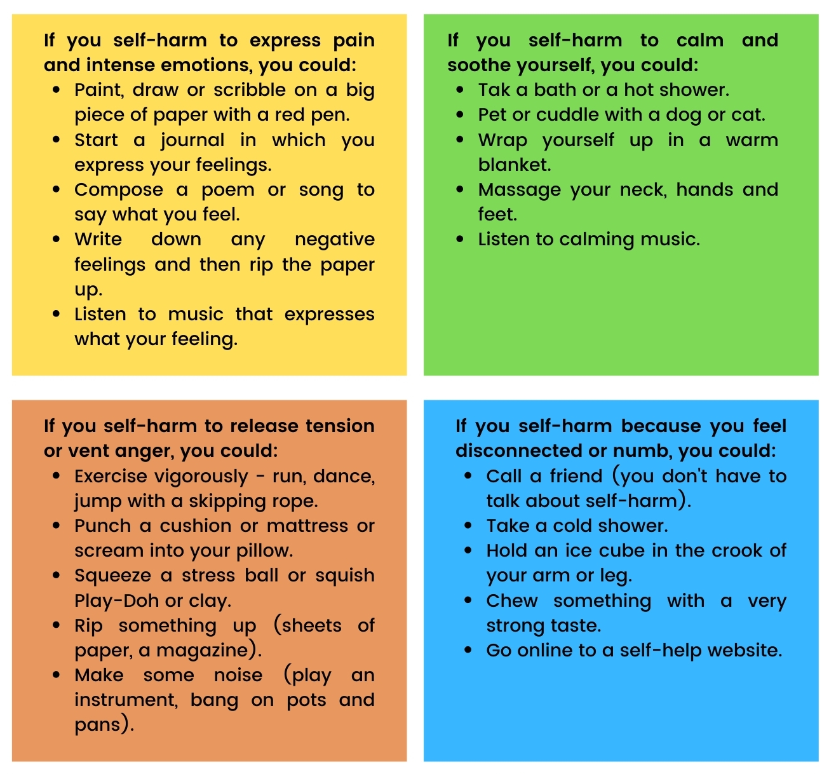

Video links:
www.youtube.com/watch?v=gTrqehlFz1w&t=6s – A young person’s journey

www.youtube.com/watch?v=b4cPCcJ6o88 – A parent’s journey

www.youtube.com/watch?v=uKGciUB8OSg – Responding to self-harm

www.youtube.com/watch?v=kT5cr-HTTEQ – Things can change

www.youtube.com/watch?v=8U8HyftKH1Q – Russell brand

Helpful websites:
www.harmless.org.uk

www.mind.org.uk

www.selfinjurysupport.org.uk

www.elefriends.org.uk

www.helpguide.org/articles/anxiety/cutting-and-self-harm.htm
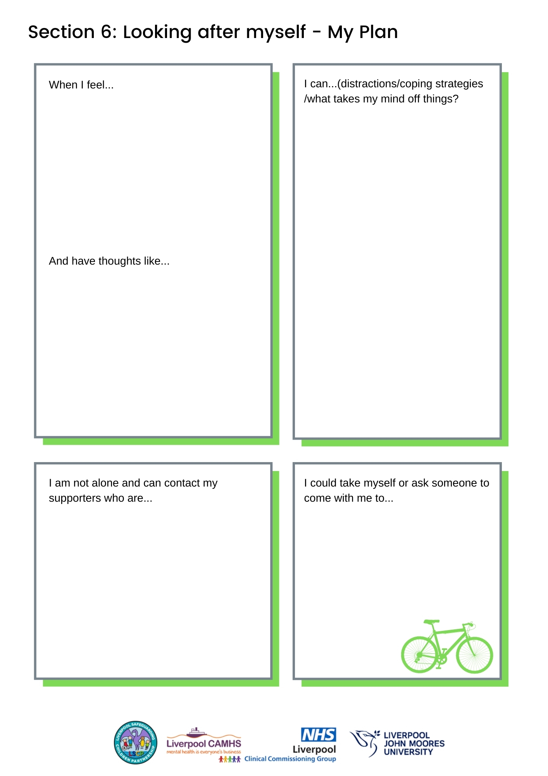

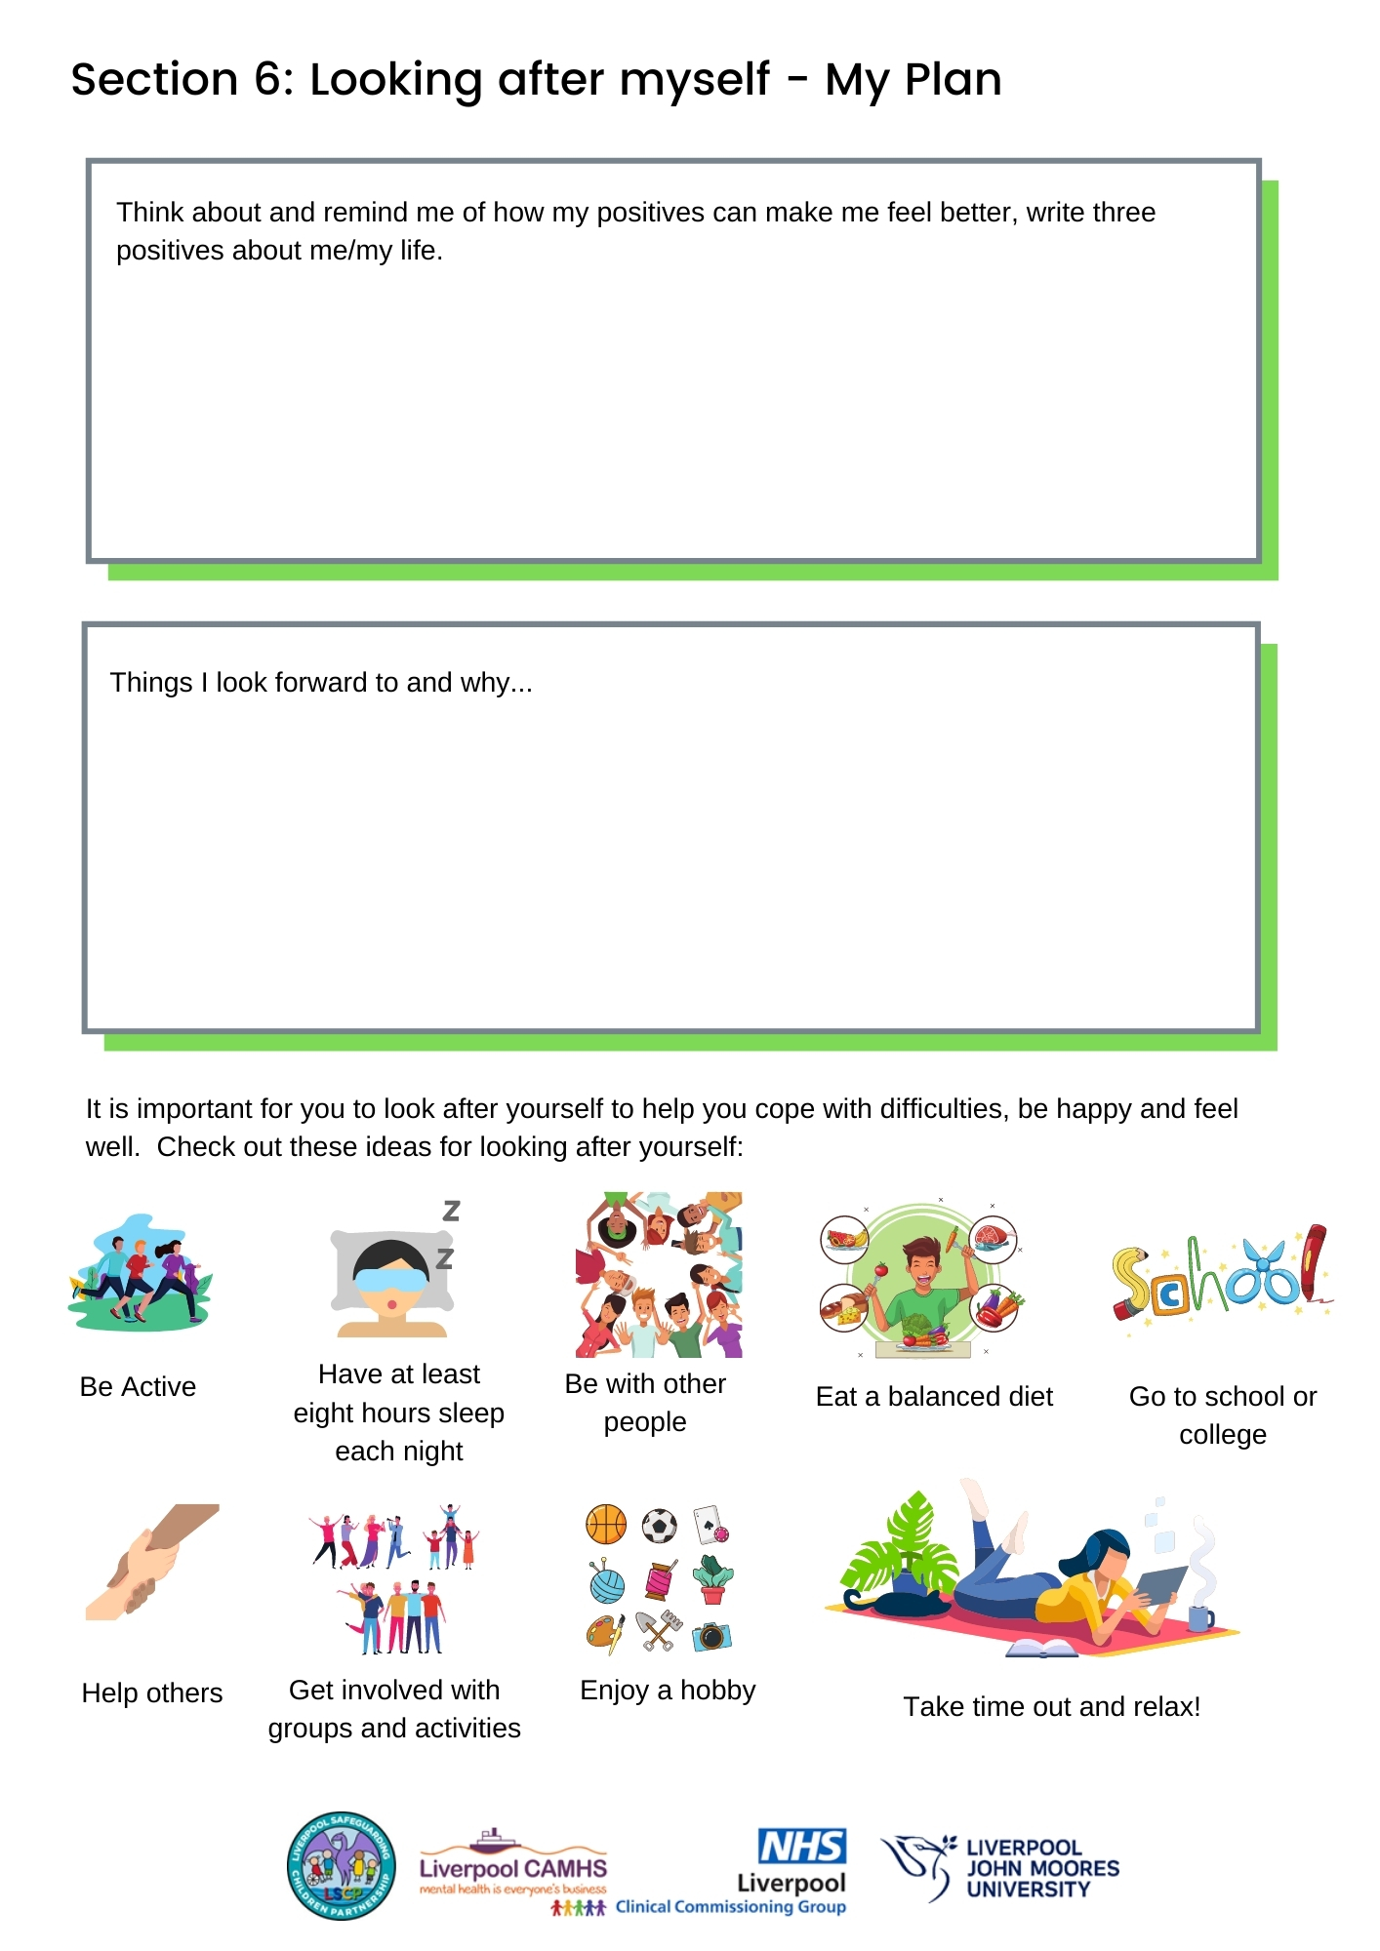

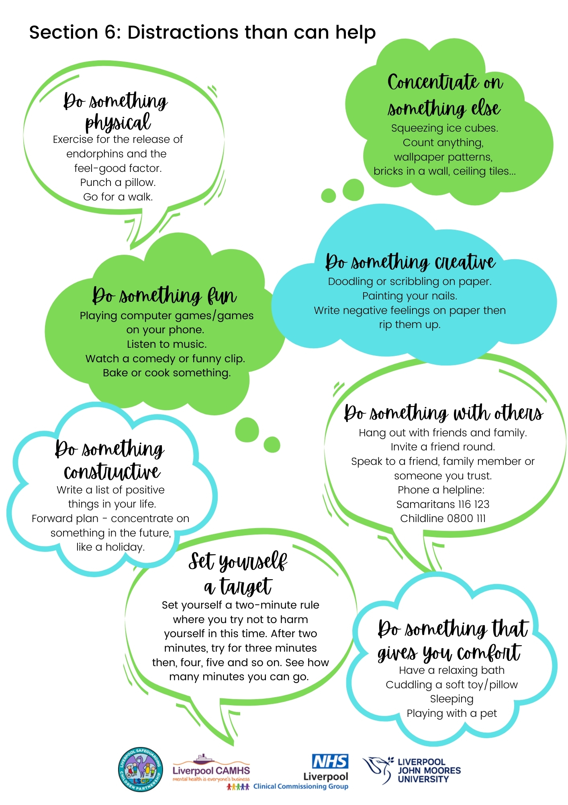

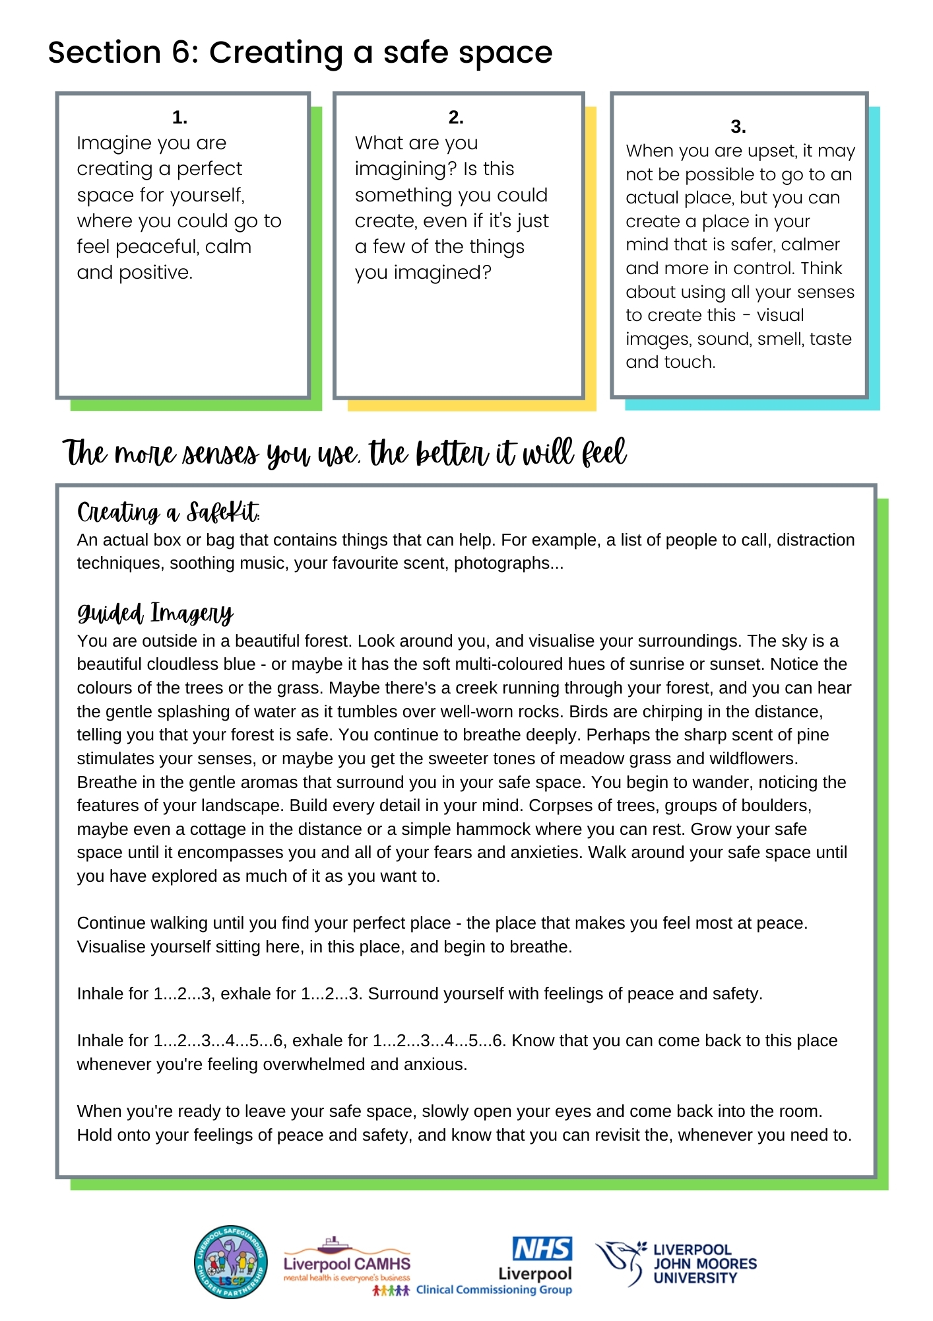

Section 7 Fact sheet on self-harm for parent/carers

As a parent/carer, you may feel angry, shocked, guilty and upset. These reactions are normal, but what that young person you care about really needs is support from you. That young person needs you to stay calm and to listen to them cope with very difficult feelings that build up and cannot be expressed. They need to find a less harmful way of coping.

What is self-harm?
Self-harm is any behaviour such as self-cutting, swallowing objects, taking an overdose, self-strangulation, running in front of a car or risk-taking behaviour, e.g. alcohol intoxication, where the intent is to deliberately cause harm to themself.

How common is self-harm?
Over the past 40 years, there has been a large increase in the number of young people who harm themselves. A large community study found that among 15- to 16-year-olds, approximately 7 per cent had self-harmed in the previous year.

Is it just attention-seeking?
Some people who self-harm have a desire to kill themselves. However, there are many other factors that lead people to self-harm, including a desire to escape, to reduce tension, to express hostility, to make someone feel guilty or to increase caring from others. Even if the young person does not intend to commit suicide, self-harming behaviour may express a strong sense of despair and needs to be taken seriously. It is not just attention-seeking behaviour.

Why do young people harm themselves?
All sorts of upsetting events can trigger self-harm, such as arguments with family, the breakup of a relationship, failure in exams and bullying at school. Sometimes several stresses occur over a short period of time, and one more incident is the final straw. Young people who have emotional or behavioural problems or low self-esteem can be particularly at risk from self-harm. Suffering a bereavement or serious rejection can also increase the risk. Sometimes, young people try to escape their problems by taking drugs or alcohol. This only makes the situation worse. For some people, self-harm is a desperate attempt to show others that something is wrong in their lives.

What you can do to help

Keep an open mind. | Help them find different ways of coping.
Make the time to listen. | Go with them to get the right kind of help as quickly as possible. Some people you can contact for help, advice and support are your family doctor, school health nurse or health visitor.

Section 8 Local & National Advice & Helplines

SCHOOL/ AEP/ ORGANISATION SAFEGUARDING LEAD | Please update with local numbers here
School nurse (usually contactable
through school or college)

Education Mental Health Team (schools only) | Contact YPAS clinical admin 0151 707 1025, or you can contact your MHST Lead/EMHP (primary schools)/ Wellbeing clinic practitioner (secondary schools) directly
CAMHS Single Point of Access/24/7 Crisis Line | Freephone 08081 963 550 or 0151 293 3577
Mersey Care 24/7 Crisis Line | Freephone 0800 145 6570
Young Persons Advisory Service YPAS | 0151 707 1025
Gay Youth Project GYRO | 0151 707 1025
Careline Children’s Services | 0151 233 3700
Merseyside Police | Non-urgent 101  Emergency 999
Health | Non-urgent 111  Emergency 999
Liverpool Safeguarding Children Partnership (LSCP)  https://liverpoolscp.org.uk/scp | Local procedures, including:  Responding to Need Guidance and Multi-Agency referral Form MARF
Own agency useful contacts:

www.childline.org.uk/info-advice/your-feelings/self-harm/self-harm-coping-techniques/

www.youngminds.org.uk/find-help/feelings-and-symptoms/self-harm/

Lesson plans - www.seemescotland.org/young-people/resources/partner-resources/

Alumina – www.selfharm.co.uk

www.kapowprimary.com/subjects/wellbeing/teacher-skills/self-harm-coping-strategies/

Harmless - www.harmless.nhs.uk/

Calm app - www.calm.com/

National advice and helplines

Beat – Beating Eating Disorders | Beat provides helplines, online support and a network of UK-wide self-help groups to help adults and young people affected by eating disorders, difficulties with food, weight or their shape.
Helpline 0345 3641414 | www.b-eat.co.uk  Youthline 0345 634 7650 (Mon to Fri 4.30pm to 8.30pm and Sat 1pm - 4.30pm)
Childline | The UK’s free NSPCC 24hrs helpline, online chat and message boards for children and young people under 18.
Freephone 0800 1111 | www.childline.org.uk
Children's Legal Centre (CORAM) | A charity that promotes children's rights and gives legal information, advice and representation to children and young people
Child Law Advice Service 0300 3305485 | www.childrenslegalcentre.com
FamilyLives | Provides information, guidance, advice and support in all aspects of family life, including bullying.
Helpline service 0808 800 2222 | www.familylives.org.uk
Talk to FRANK | Friendly confidential drug advice.
Helpline 0300 123 66 00 (24 hours) | www.talktofrank.com
Get Connected | Free, confidential telephone helpline service for young people who need help but don’t know where to turn
Freephone 0808 808 4994 | www.getconnected.org.uk
Harmless | Support providing a range of services about self-harm, including support, information, training and consultancy to people who self-harm
 | www.harmless.org.uk/
Hearing Voices Network | Information and support for people who hear voices, see visions or have other unusual perceptions
0114 271 8210 | www.hearing-voices.org
Karma Nirvana | Supporting victims of honour crimes and forced marriages
Helpline 0800 5999247 | www.karmanirvana.org.uk
LifeSIGNS | Self-injury guidance and Network Support
 | www.lifesigns.org.uk
MIND | Advice, information and support for anyone experiencing a mental health problem
MIND Infoline 0300 123 3393 | www.mind.org.uk
National Self-Harm Network | Online support forum for people who self-harm provides free information pack to service users
 | www.nshn.co.uk
NSPCC | Information, advice and support services about preventing child abuse.
professional’s helpline 0808 800 5000 | www.nspcc.org.uk
PAPYRUS Prevention of Young Suicide | Provides a range of services, including information, advice and support to help reduce young suicide
HOPEline UK 0800 068 41 41 | www.hopelineuk.org.uk
RU-OK | Helping young people helping themselves - coping with common, and sometimes serious problems, as well as using your strengths
 | www.ruok.org.uk
Samaritans | Confidential emotional support for anybody in crisis. Samaritans volunteers listen in confidence to anyone in any type of emotional distress, without judging or telling people what to do
Free helpline 116 123 | www.samaritans.org.uk
The Butterfly Project | An anonymously run blog supporting young people with coping techniques which include drawing butterflies around cut marks.
 | www.butterfly-project.tumblr.com
The Site | An online 24/7 guide to life for 16 to 25 year-olds. It provides non-judgmental support and information on everything from sex and exam stress to debt and drugs. Online advice, forums apps and tools
 | www.thesite.org
Young Minds | Range of information, advice, support services for young people, parents and professionals to improve the emotional well-being and mental health of children and young people.
Parent helpline 0808 8025544 | For young people http://www.youngminds.org.uk/for_children_young_people
Youth Access | A national membership organisation for youth information, advice and counselling agencies. Provides information on youth agencies to children aged 11-25 and their carers but does not provide direct advice.
 | www.youthaccess.org.uk to search their directory of services for help.

Section 9 Multi-agency self-harm decision-making guidance ‘do’s and don’ts’ /information for practitioners/Important contacts

Protective and supportive action is the general approach to be taken.

What matters for many young people is having someone to talk to, a trusted adult, who will take them seriously. Previous studies have found that most people want to be able to talk about self-harm and help young people but do not have the language/vocabulary to communicate effectively.

A supportive response is one that demonstrates respect and understanding together with a non-judgmental stance, with a focus on the person, not what they have said or done. Try to find out about not only the risks and vulnerabilities but also about any particular strengths and protective factors (see Section 1 of the Toolkit).

Remember, most young people who self-harm do not have mental health problems – they are feeling overwhelmed and have no other means of managing their emotions. They also feel shame and stigma – it may not be easy for them to talk about it.

Do | Don’t
Listen and care. This is the most important thing you can do.  It might not seem much, but showing that you want to know and understand can make a lot of difference. They may find it more helpful if you focus on their feelings, and this shows that you understand that, at that time, self-harm works for them when nothing else can. | Tell them off (e.g. this behaviour is wrong’) or punish them in some way. This can make the person feel even worse, so could lead to more self-injury.
Accept mixed feelings. They might hate their self-harm, even though they might need it. It helps if you accept all of these changing and conflicting feelings. | Jump in with assumptions about why they are self-harming. Different people have different reasons, and it’s best to let them tell you why they do it.
Help them find further support. They may need help in addition to what you can give - you can support and encourage them in finding this. | Blame them for your shock and/or upset. You have a right to feel these things, but it will not help if you make them feel guilty about it.
Show concern for their injuries. If the person shows you a fresh injury, offer the appropriate help in the same way as if it was an accident. Don’t overreact just because it is self-inflicted. | Treat them as mad or incapable. This takes away their self-respect and ignores their capabilities and strengths.
Voice any concerns you have. Make sure you also listen to their feelings about what they want to happen. Work out together a way of taking care of their health and safety. | Try to force them to stop self-harming. Doing things like hiding razor blades or constantly watching them doesn’t work and is likely to lead to harming in secret, which can be more dangerous.
Recognise how hard it may be for them to talk to you. It may take a lot of courage for them to discuss their self-harm and feelings, and it may be difficult for them to put things into words. Gentle, patient encouragement can help. | Panic and overreact. This can be very frightening for the person. It is better to try and stay calm and take time to discuss with them what they would like you to do for them or the next steps they’d like to take.
Help them find alternatives to self-harm (there are lots of distracting techniques in section 4 of the Toolkit) | Avoid talking about self-harm. It won’t make it go away but will leave them feeling very alone
 | Ask them to promise not to self-harm. This will not work but is likely to put a lot of emotional pressure and can set them up to feel guilty.

Simple things you can say:

‘I’ve noticed that you seem bothered/worried/preoccupied/ troubled. What has happened?’
‘I’ve noticed that you have been hurting yourself. What has happened to you?’

Conversation prompts

Topic | Possible prompt questions
Confidentiality | “I appreciate that you may tell me this in confidence, but it’s important that I let you know that your safety will always be more important than confidentiality. If I am sufficiently worried that you may be feeling unsafe or at risk of hurting yourself, part of my job is to let other people who can help you know what’s going on, but I will always have that discussion with you before and let you know what the options are so that we can make these decisions together.”
Starting the conversation/  establishing rapport | “Let’s see how we can work this out together. I may not have the skills to give you the help you need, but we can find that help for you together if you would like.”  Use active listening - for example: “Can I just check with you that I have understood that correctly?”
The nature of the self-harm | “Where on your body do you usually self-harm?”  “What are you using to self-harm?”  “Have you ever hurt yourself more than you meant to?”  “What do you do to care for the wounds?”  “Have your wounds ever become infected?”  “Have you ever seen a doctor because you were worried about a wound?”
Reasons for self-harm | “I wonder if anything specific has happened to make you feel like this or whether there are several things that are going on at the moment? Can you tell me a little more?” For example, peer relationships, bullying, exam pressure, difficulties at home, relationship break-up or substance misuse or abuse.
Coping strategies and support | “Is there anything that you find helpful to distract you when you are feeling like self-harming? Perhaps listening to music, playing on your phone, texting a friend, spending time with your family, reading or going for a walk?”  “I can see that things feel very difficult for you at the moment, and I’m glad that you have felt able to talk to me. Is there anyone else that you have found helpful to talk to before, or is there anyone you think may be good to talk to? How would you feel about letting them know what’s going on for you at the moment?”  “How could we make things easier for you at school?”  “What feels like it is causing you the most stress at the moment?”  “What do you think would be most helpful?”
Speaking to parents (where appropriate) | “I understand that it feels really hard to think about telling your parents, but I am really concerned about your safety, and this is important. Would it help if we did this together? Do you have any thoughts about what could make it easier to talk to your parents?”
Ongoing support | “Why don’t we write down a plan that we have agreed together? Then you will always have a copy that you can look at if you need to remind yourself about anything. Sometimes when you are feeling low or really want to self-harm, it is difficult to remember the things you have put in place - this can help remind you”.
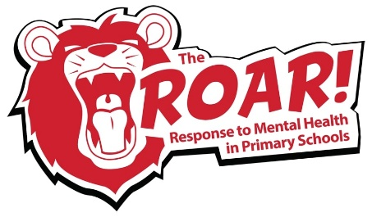
Overall, the ROAR Response needs to be at the forefront when supporting children and young people, Recognising the signs and symptoms, asking Open questions (try to spot the BIG thought), Access support, services and self-care, and building Resilience.

Decision-making guidance

Remember: No two people self-harming are the same. Everyone self-harms for different reasons and with different intent. Most people who self-harm are not suicidal or a risk to other people. Every episode of self-harm should be treated individually.

If you come into contact with someone you know is, or believe to be self-harming…

Take advice from your manager and adopt a ‘Team Around the Child’ approach if:
- They do not appear distressed.
- They are cooperative, communicative and making good eye contact.
- Have a supportive, non-judgmental social network.
- They are talking positively about the future and have things they are looking forward to
- There was no suicidal intent behind the act of self-harm.

This would include completing an Early Help Assessment Tool (EHAT), which would then identify the child’s needs and facilitate referral to any support services.

Get advice from a GP
- If you are in doubt about physical health needs as a result of self-harm.

Get advice from CAMHS (freephone 08081 963 550 or 0151 293 3577) if:
- You believe the child/young person was attempting to complete suicide.
- The child or young person thought the act of self-harm would result in serious injury.
- There has been an escalation in method from previous self-harm, i.e. cutting on a forearm has moved to cutting near arteries.
- You believe a child or young person has a plan in place to end their life, and there is a possibility they could act on this.

Refer to Children’s Social Care if:
- The child and/or family have serious or complex social needs which need further assessment or intervention.
- There is an indication or suspicion that abuse or exploitation may be present.
- Support around the child and family is failing to reduce the risk for the child.

Take to A&E or call an ambulance if:
- It is reported to you, or you have observed a child overdosing or ligaturing.
- You believe the child/young person requires medical attention due to uncontrollable bleeding.
- You believe there is a possible risk to life as a result of self-harm.
- You believe a child or young person has a plan in place to end their life, and there is a likelihood they will act on this.

Call the police if:
- You think a child or young person is at imminent risk of suicide.

If ever you are in doubt, you have a duty to safeguard the young person, and CAMHS are there to give you support and advice. This does not mean they will assess every young person face to face but will support you in decision making where required.

Important Local Contacts

SCHOOL/ AEP/ ORGANISATION SAFEGUARDING LEAD | Please update with local numbers here
School nurse (usually contactable
through school or college)

Education Mental Health Team (schools only) | Contact YPAS clinical admin 0151 707 1025, or you can contact your MHST Lead/EMHP (primary schools)/Wellbeing clinic practitioner (secondary schools) directly
CAMHS Single Point of Access/24/7 Crisis Line | Freephone 08081 963 550 or 0151 293 3577
Mersey Care 24/7 Crisis Line | Freephone 0800 145 6570
Young Persons Advisory Service YPAS | 0151 707 1025
Gay Youth Project GYRO | 0151 707 1025
Careline Children’s Services | 0151 233 3700
Merseyside Police | Non-urgent 101  Emergency 999
Health | Non-urgent 111  Emergency 999
Liverpool Safeguarding Children Partnership (LSCP)  https://liverpoolscp.org.uk/scp | Local procedures, including:  Responding to Need Guidance and Multi-Agency referral Form MARF
Own agency useful contacts:

Cl

NICE Guideline NICE clinical guideline 16 www.nice.org.uk/cg16 Self-harm: The short-term physical and psychological management and secondary prevention of self-harm in primary and secondary car
Klonsky, E., et al. (2011). Non-suicidal Self-Injury. Toronto, ON. : Hogrefe Publishing.
Office for National Statistics (2020). Suicides in England and Wales: 2019 registrations.
https://www.research.manchester.ac.uk/portal/files/162072409/NCISH_2019_Report.pdf
Klonsky, E., May, A. & Glenn, C. (2014). The relationship between non-suicidal self-injury and attempted suicide: Converging evidence from four samples. Journal of Abnormal Psychology, 122(1), 231-237
Burton et al. (2014). An Introduction to Child and Adolescent Mental Health. London: Sage;
Whitlock, J. & Knox, K. (2007). The relationship between self-injurious behaviour and suicide in a young adult population. JAMA Paediatrics, 161(7), 634-640.
McManus S, et al. (2016) ‘Chapter 12: suicidal thoughts, suicide attempts and self-harm,’ in McManus S, Bebbington P, Jenkins R, Brugha T. (eds) Mental health and wellbeing in England: Adult Psychiatric Morbidity Survey 2014. Leeds: NHS Digital.
https://www.therecoveryvillage.com/mental-health/self-harm/related/self-harm-statistics/#SelfInjury_Prevalence
NHS Digital. (2018). Mental Health of Children and Young People in England, 2017: Summary of Key Findings. Retrieved from: https://files.digital.nhs.uk/F6/A5706C/MHCYP%202017%20Summary.pdf
Royal College of Psychiatrists (2020). Self-harm in young people: for parents and carers
Burton, M. (2019). Suicide and Self-harm: vulnerable children and young people. https://www.magonlinelibrary.com/doi/full/10.12968/pnur.2019.30.5.218
Royal College of Psychiatrists (2018). Young people who self-harm: A guide for school staff
Burton, M. (2019). Suicide and Self-harm: vulnerable children and young people. https://www.magonlinelibrary.com/doi/full/10.12968/pnur.2019.30.5.218
Royal College of Psychiatrists (2018). Young people who self-harm: A guide for school staff
Royal College of Psychiatrists (2018). Young people who self-harm: A guide for school staff

