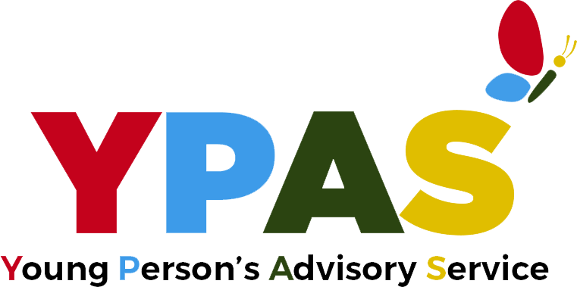
GRAB YOURSELF A BREW AND JOIN US

Booking form for coffee mornings

PARENT/CARER FULL NAME

PARENT/CARER DOB

CHILD/S FULL NAME

CHILD/S DOB

ADDRESS

CONTACT NUMBER

EMAIL ADDRESS

AGREEMMENT:
BY AGREEING TO TAKE PART IN THE YPAS COFFEE MORNINGS YOU ARE AGREEING FOR YPAS TO STORE YOUR INFORMATION ON THE SECURE DATA BASE
YOUR INFORMATION WILL NOT BE SHARED AND IS CONFIDENTIAL. YOU ARE ALSO REQUIRED TO RESPECT OTHER PARENTS /CARERS COFIDENTIALITY DURING COFFEE EVENTS HELD BY YPAS
OUR COMMITMENT TO YOU :
WE ARE COMMITTED TO OFFERING YOU OUR CONFIDENTAIL SPACE
IMPARTING INFORMATION TO YOU THAT WE FEEL IS RELEVENT TO THE THEME OF THE COFFEE EVENT
SENDING ANY RELEVENT INFORAMTION VIA EMAIL TO YOU (YOU CAN ASK US TO DELETE YOUR EMAIL ADDRESS AT ANY TIME)
www.ypas.org.uk 0151 707 1025 support@ypas.org.uk

